**Foundation of Artificial Intelligence**

# PLAGIARISM DECLARATION

1. I confirm that this assignment is my own work and is not copied from another person's work.
2. I acknowledge that copying someone else’s assignment, or part of it, constitutes a form of plagiarism.
3. I have not allowed anyone to copy my work or part of it, with the intention of passing it off as their own work.

|  |  |
| --- | --- |
| Name: Dennis Ng Han Jie | Admin: 204461H |

Signature: Date: 19/1/23

# Question 1 Clustering of templates of different shapes (6 marks)

## Explain how the clustering model in section a) can group templates of similar features into the same group. (3 marks)

Firstly, the imported images are passed through a neural network such as Inception v3, so that it can apply filters onto them, and extract features out from the images into a vector representation which is done through the Image Embedding widget. Then with these vector representations, it is passed through the Distances widget which calculates the distance between each vector using the Cosine Similarity formula. This is to determine how similar each vector is, based on how close the distance is to each other, it can then be clustered accordingly into the four groups using the Hierarchical Clustering widget.

## If the clustered result from a) is used to develop a machine learning classifier, what are the potential groups will be misclassified? Show and justify the problem described. (2 marks)

Squares and triangles. Even though they can be correctly clustered based on the data that is given, there is a possibility that the model may misclassify the squares and triangles as each other.

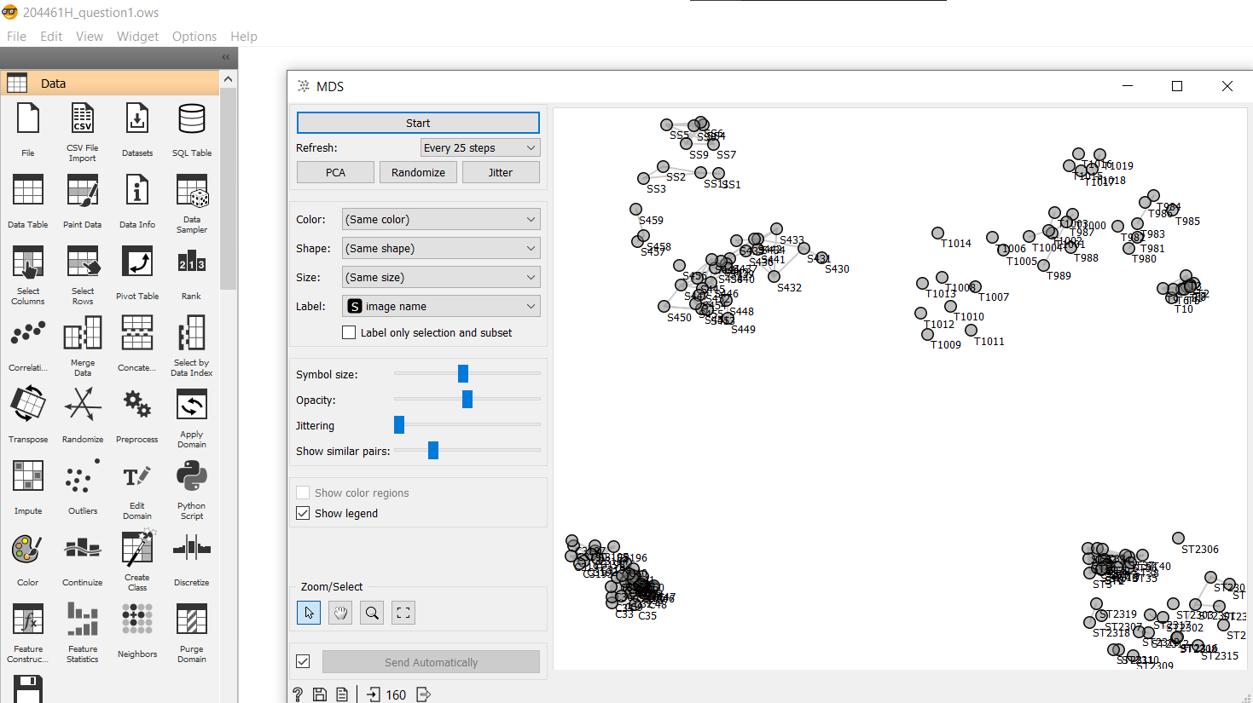

This is because when using MDS to plot the distances, the squares and triangles are relatively close to each other, rather than distinctly separated such as the circles and stars, this may be due to the features that were extracted by the Inception v3 not being distinct enough thus there may be a possibility that the model might misclassify the squares and triangles. Furthermore, Hierarchical Clustering is sensitive to outliers, thus the performance may degrade.

# Question 2 Classification of Notes authenticity (5 marks)

## Explain what is the purpose of the training, validation and test data (1 mark)

Training data is used to train the model, validation data is used to evaluate the trained model while also using it to tune the hyperparameters, and test data is used to evaluate the trained model and only used when the model has been fully trained.

The purpose of the validation data is to tune the hyperparameters to ensure that the model can generalize allowing it to adapt to new or never seen before data, preventing overfitting.

Test data is then used to test that the model can generalize as this set of data has not been used to train the model with, thus it will be able to show an accurate representation of the model’s performance.

## If you are given only a choice to use one of the features(m1,m2,m3,m4), which feature will you choose to give the best classification? Justify your choice. (2 marks)

M1. With only M1, it provides the highest F1 score, which is used to measure the accuracy based on a dataset, and AUC – ROC curve, which is used to tell how well the model can distinguish between the classes compared to the using only one of the other features. The higher the number for F1 score and AUC – ROC curve, the better. Thus, this shows that M1 has the most weight, which has the largest influence on how well the model can predict the correct prediction, and therefore it should be used rather than the other three.

# Question 3 Prediction of insurance price using Regression models (8 marks)

## With the given dataset develop a machine learning linear regression model predictor. Split the dataset into a train and test set. Train the model using the training dataset, then test the trained model with the test set. You should achieve R2 of at least 0.7 using the test dataset. Screen capture the result and include it in the submission document (3 marks)

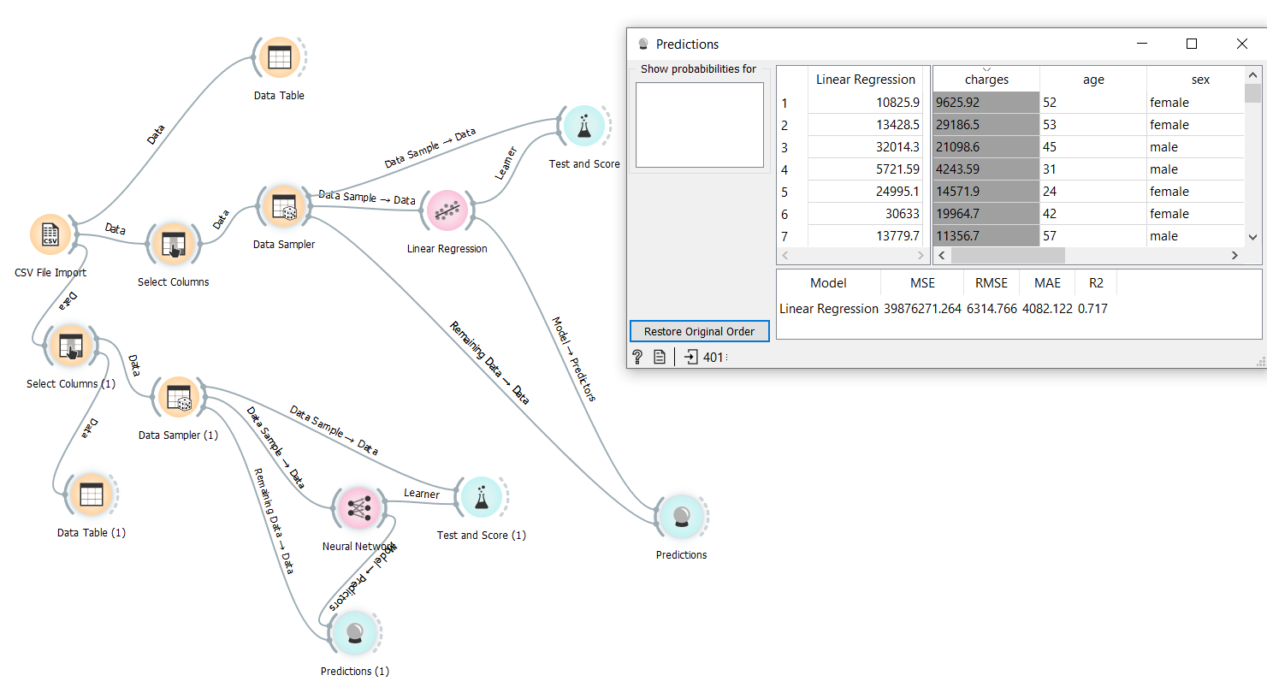

## With the given dataset develop a deep learning linear regression model predictor. Split the dataset into a train and test set. Train the model using the training dataset, then test the trained model with the test set. You should achieve R2 of at least 0.8 using the test dataset. Screen capture the result and include it in the submission document (3 marks)

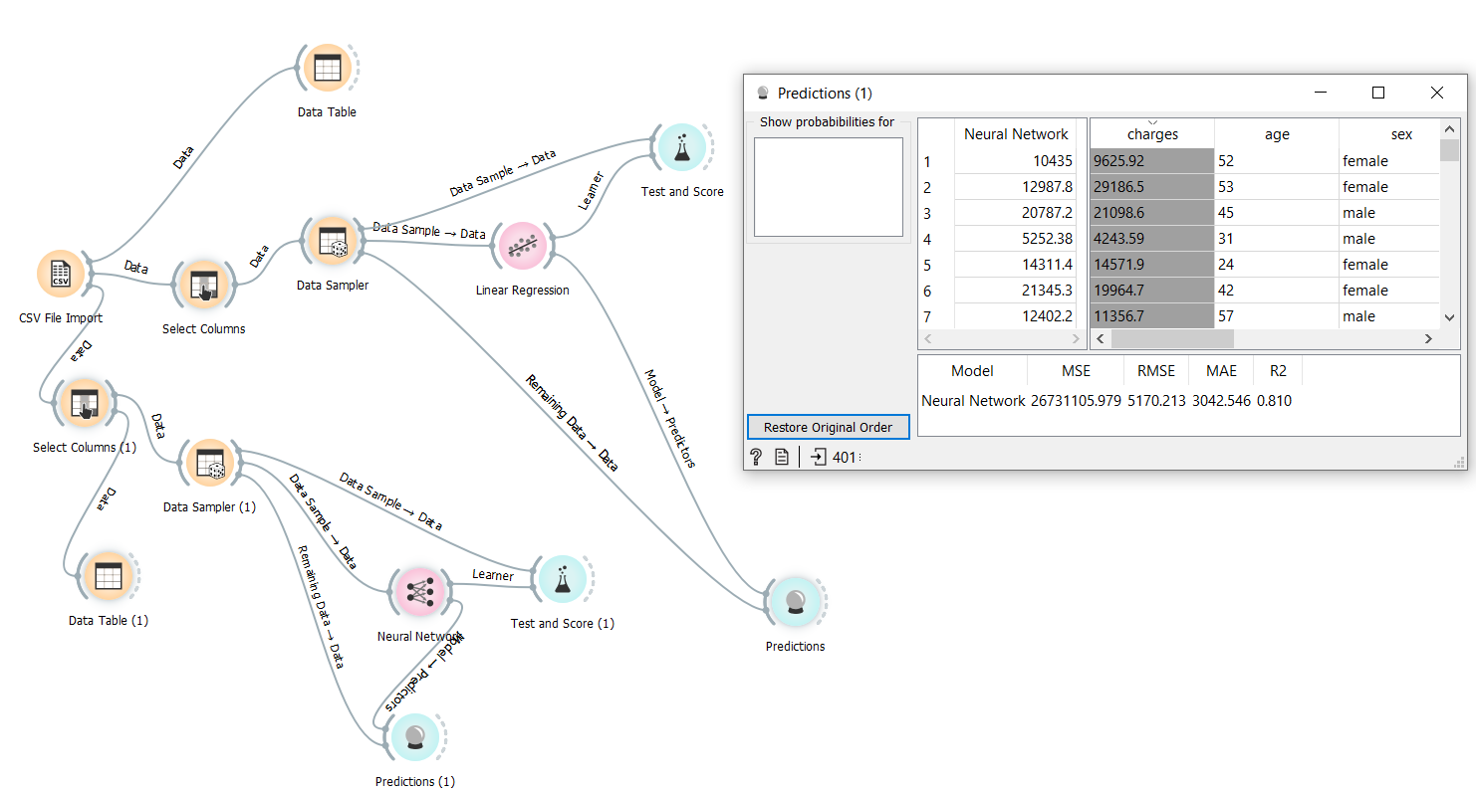

## Use AI Ethics fairness principle to evaluate the insurance.csv dataset. Justify and comment on the potential fairness issue(s) that could happen when we use this dataset to develop a machine learning prediction application. ( 2 marks)

There may be biasness or discrimination due to the dataset containing the sex, and the region of the person. This is because the AI model may be using these columns to determine if the relation between the sex, or region with the charges for its prediction. Thus, there is a possibility that it may lead to skewed values depending on the person’s gender and region, violating the AI Ethics fairness principles, leading to unfair results.

However, even if the columns were to be removed, there might still be a bias as the dataset may have already been biased when collecting the data depending on how it was collected.

# Questions 4 Topics Classification from the text (6 Marks)

## Explain how the text encoding method Bag of Word extract features to be used in training the machine learning model(2 marks)

Bag of Word splits the sentences into a list, for instance the sentence “I like Artificial Intelligence”, will be split into “I”, “like”, “Artificial”, and “Intelligence”. Thus, any information about the order or structure of the sentence will be removed. With Term Frequency set to “Count”, it will calculate the number of times each word occurs, then with the Document Frequency set to “Inverse Document Frequency”, it helps the model with weighting the words, which is to determine which words it should look out for rather than assuming that all words are equally important. Afterwards, this information along with the labels of the topic is passed on to train the machine learning model by finding a relation between the number of times a word occurs and the topic, allowing it to learn which topics would contain specific words. The model is then able to predict what topic it would be based on the words that appear in the document.

## Given the scenario. (This hypothetical question does not refer to your previous result in a) After performing training and testing, you notice that the accuracy of the training is 97% however your testing accuracy is only 65%. Describe what is the possible cause of the results. List and explain two possible ways to improve the test accuracy. (2 marks)

This is caused by overfitting, which may be due to a bad dataset, or the model was not able to generalize the dataset enough, or other factors. Thus, it would only perform well on data that it has been trained with previously, and not on others which caused the training and testing accuracies mentioned in the scenario.

One way to improve is by using regularization methods such as Lasso (L1), or Ridge (L2). These methods will regularize or reduce the coefficients of features towards zero, thus helping the model to generalize better, allowing the model to adapt to unknown data better.

Another way to improve is by adding more data, especially of those that the model was unable to determine accurately. With more data, the model will then be able to recognize the features better, leading to better accuracy. However, it is important to note that the data must be cleaned beforehand and is relevant, otherwise it will lead to even more overfitting or even worser accuracy instead.

# Questions 5 Image Classification Problems (5 Marks)

## The model test set F1 score must be at least 0.8. Screen capture the result and include it in the submission document ( 1 mark)

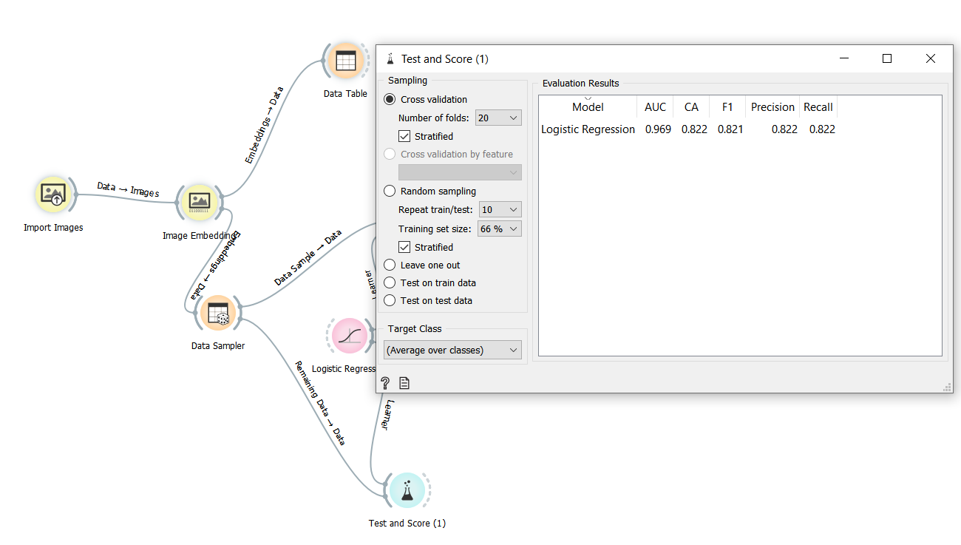

## From the F1 score you have achieved from b), can you conclude that all the 6 classes can perform well in the prediction for new unknown images? Show and explain your conclusion given.( 2marks)

No. The F1 score is merely a way to represent the rate of the model in predicting the true value of the dataset. Thus, F1 score alone cannot be used to determine if it is able to do well in predicting unknown images. Instead, metrics such as the AUC value should be looked at as well, AUC determines how well the model is able to distinguish between each class, thus with it being a higher value, it shows that the model is able to distinctively tell which class the image belongs to. However, it is still best to test the model against the unknown images itself as it will provide the most accurate representation of how well it will do in a real-world scenario as there may be unexpected factors leading to unexpected results.